Troop 219 Service Project–“Trick or Treat in the Heat.” http://totith.org

Hi everyone, I am sending this message, hoping that Troop 219 will approve service hours for and participate in a Heritage Estates community event that last year raised over $14 000 for cancer charities in Alaska. The event is TOTITH (Trick or Treat in the Heat), and it takes place on Sunday September 13th, from 5:00-7:00pm.

For those who may not be familiar with this event; it is a charity event that raises money for:

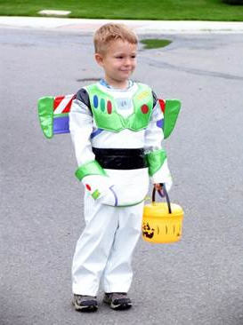
- Hospice of Anchorage (hospiceofanchorage.org)
- Make a Wish Foundation (akwa.wish.org)
- Ronald McDonald House Charities (rmhcseattle.org)

TOTITH started in 2005 as an impromptu block event to allow a terminally-ill five year old to experience one last Trick or Treat before he died. However, all participants had so much fun that it is now a highly-anticipated neighborhood-wide charity fundraiser.

This would be for the Heritage Estates neighborhood in Eagle River, the neighborhood just north of Walmart.(5 min from JLC).

I was thinking that we could create 4 different shifts
(2 hours each) for those boys who can only participate for a short time, but the boys who want to and have the time; can stay for 2 shifts or for the entire event. Approx. noon-8pm.

Shift 1: 5 Scouts are needed during the day to help blow up balloons-perhaps starting at about noon-4pm

Shift 2: Setup (3-5 pm)
Setting up games for the kickoff party
Manning games such as bean bag toss and fishing game-games will be played from 4:30-5pm
Setting up tables for donation stations and balloon selling stations

Shift 3: During the event (5-7pm)
Manning donation stations
Manning balloon selling stations
Delivering candy to houses running low

Shift 4: If some could stay until 8, we need help with taking down signs and final clean up.

If we could have rough numbers of Scouts willing to help at different times by August 31, that would be really helpful!

Thank you so much for considering our event for service work! We would love to have the presence of the Boy Scouts. We usually sell 1200 wristbands for this event, it is quite busy for a short amount of time and any help is greatly appreciated!

Anjela Pemberton (907) 854-8158

